**ENCORE README**

Thank you for downloading ENCORE (ECHO Native Circadian Ontological Rhythmic Explorer)! ENCORE is an app designed to help you navigate and understand the function of amplitude change categories for circadian rhythms with gene ontologies. This guide will lead you in first time set-up and use. Pictures have been provided for ease of use, using Windows 10. An asterisk indicates the step has an explanation below, and a tilde indicates the step is first-time set up only.

Last updated: 2/8/19 (ENCORE version 0.1)

Steps:

1. *~ Download Firefox (https://www.mozilla.org/en-US/firefox/new/) or Chrome (https://www.google.com/chrome/browser/desktop/index.html) and make it your default browser.
2. ~ Download the protein links for *your organism* from STRING (https://string-db.org/cgi/download.pl). The organisms that are available in this application are:

|  |  |
| --- | --- |
| **Organism** | **Taxonomy Number** |
| Mus musculus | 10090 |
| Homo sapiens | 9606 |
| Neurospora crassa | 5141 |
| Drosophila melanogaster | 7227 |
| Anopheles gambiae | 7165 |
| Saccharomyces cerevisiae | 4932 |
| Escherichia coli K12 substr MG1655 | 511145 |

Enter your organism’s name in the ‘choose an organism’ box and click update. You should then see the taxonomy number preceding the file names. Download the file called TAX#.protein.links.v11.0.txt.gz:

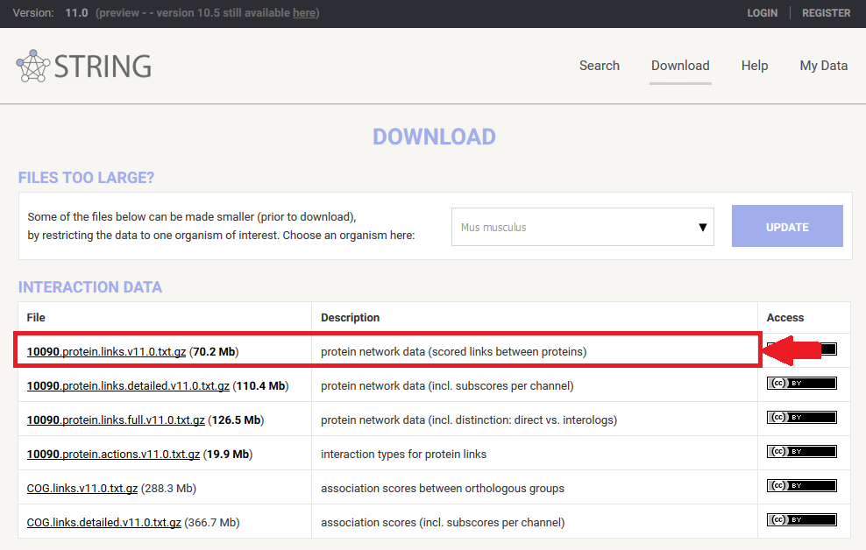

1. ~ Once you’ve downloaded that file, extract the text file. (You may need to download an alternative unzip program that can unzip .gz files, such as 7Zip [https://www.7-zip.org/].) Place that text file, unaltered, in the ‘links’ folder of the ‘ENCORE Shiny App’ Folder.

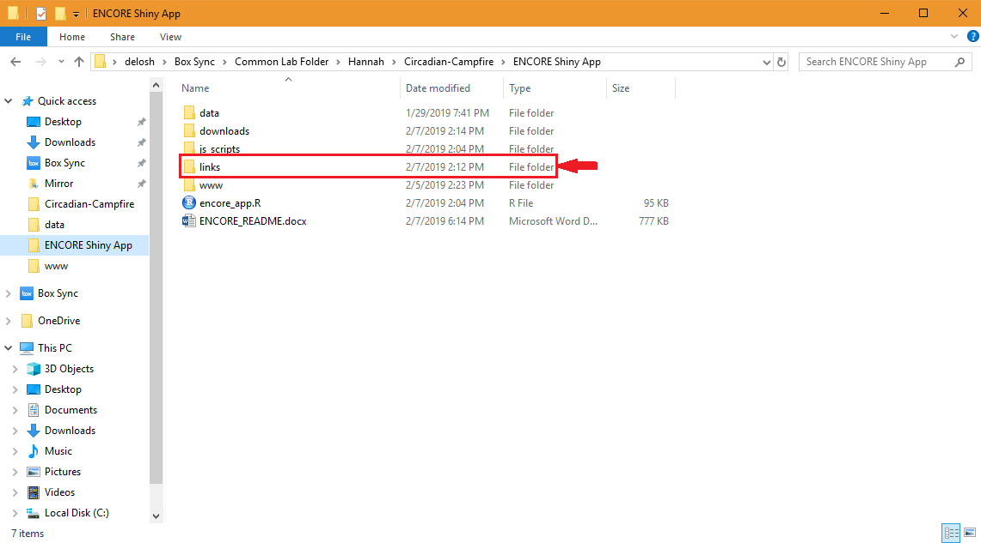

1. ~ Download R, if you do not already have it: https://www.r-project.org/
2. ~ Download RStudio, if you do not already have it (RStudio Desktop is sufficient): https://www.rstudio.com/products/rstudio/download/
3. Plug in your computer, if it is not plugged in already.
4. Open RStudio. It should look something like this:

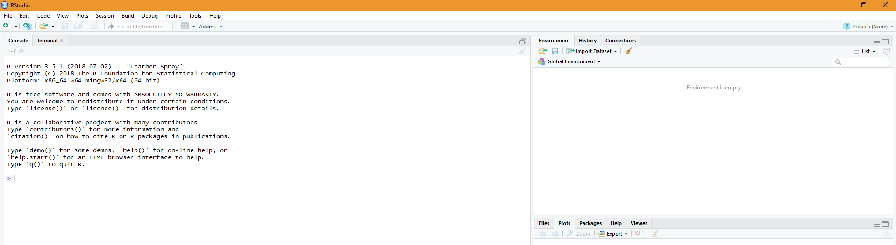

1. ~ Copy and paste the following text into the console window (bottom right window of the RStudio Session), then press enter:

install.packages("rstudioapi")

install.packages("shiny")

install.packages("ggplot2")

install.packages("r2d3")

install.packages("data.table")

install.packages("jsonlite")

install.packages("igraph")

install.packages("stringr")

if (!requireNamespace("BiocManager", quietly = TRUE))

install.packages("BiocManager")

BiocManager::install("STRINGdb", version = "3.8")

BiocManager::install("AnnotationHub", version = "3.8")

BiocManager::install("mygene", version = "3.8")

BiocManager::install("AnnotationDbi", version = "3.8")

BiocManager::install("org.Ag.eg.db", version = "3.8")

BiocManager::install("org.Dm.eg.db", version = "3.8")

BiocManager::install("org.Hs.eg.db", version = "3.8")

BiocManager::install("org.Mm.eg.db", version = "3.8")

BiocManager::install("org.EcK12.eg.db", version = "3.8")

BiocManager::install("org.Sc.sgd.db", version = "3.8")

This will install these packages (a set of functions that this application uses) onto your computer. This may ask for your input, so just say no to the questions asked. If you run into errors saying “no,” just say yes instead. Note: this may take some time.

1. Open encore_app.R, which should be included in the .zip file you downloaded and also contained this README. It should open in the top left window of your RStudio session.

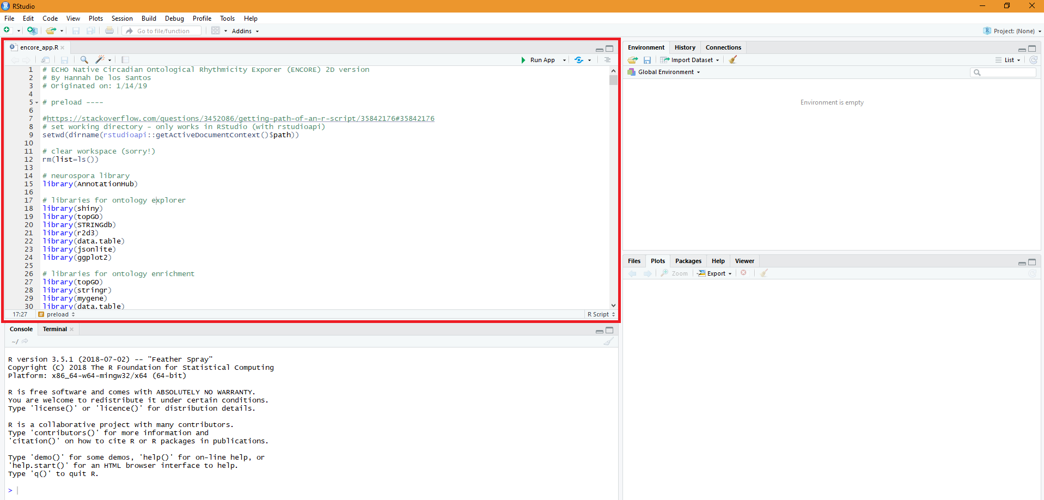

1. In the top right corner of the encore_app.R window, you should see the button, “Run App”. Click on the small downwards arrow next to it and choose “Run External”.

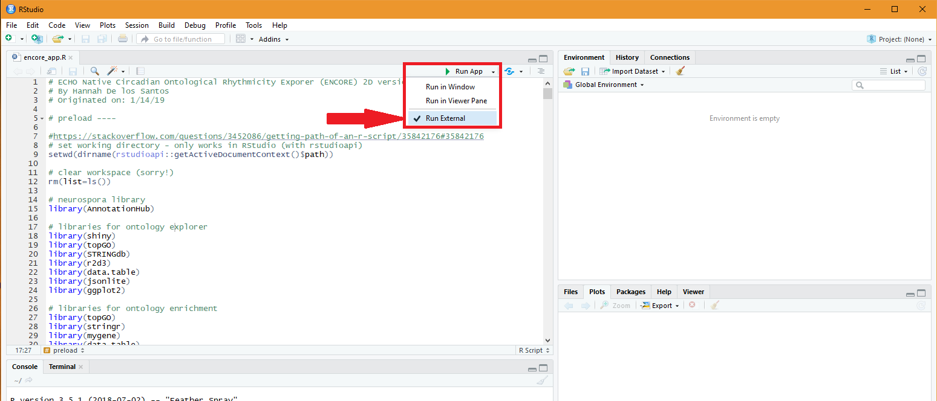

1. Now click “Run App”. This should open the ENCORE application in your now default browser window (either Firefox or Chrome). The picture below is a representation in Firefox.

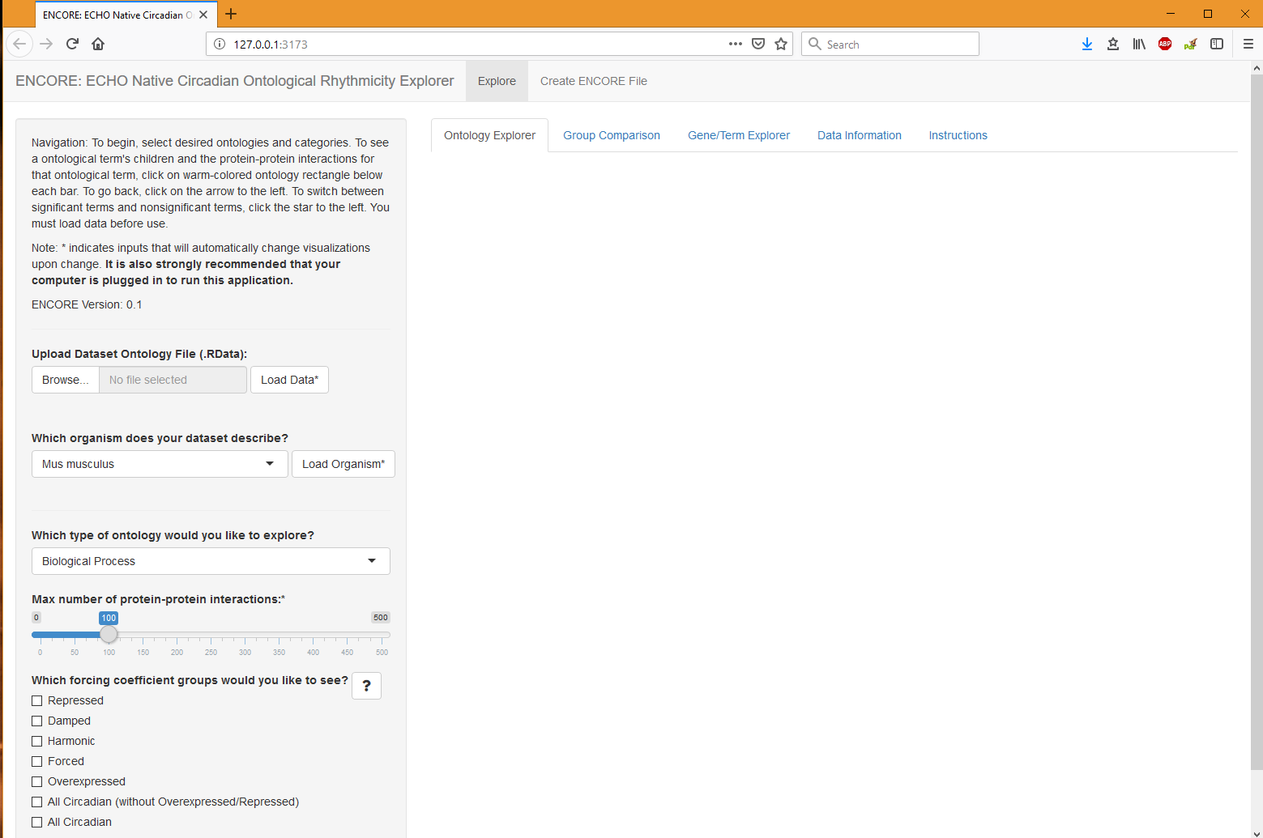

1. Start by choosing the ‘Create ENCORE File’ section to calculate your ECHO (https://github.com/delosh653/ECHO) output for ENCORE and download resulting file. ENCORE downloads appear in the ‘downloads’ folder of the ENCORE Shiny App folder that you’ve downloaded.

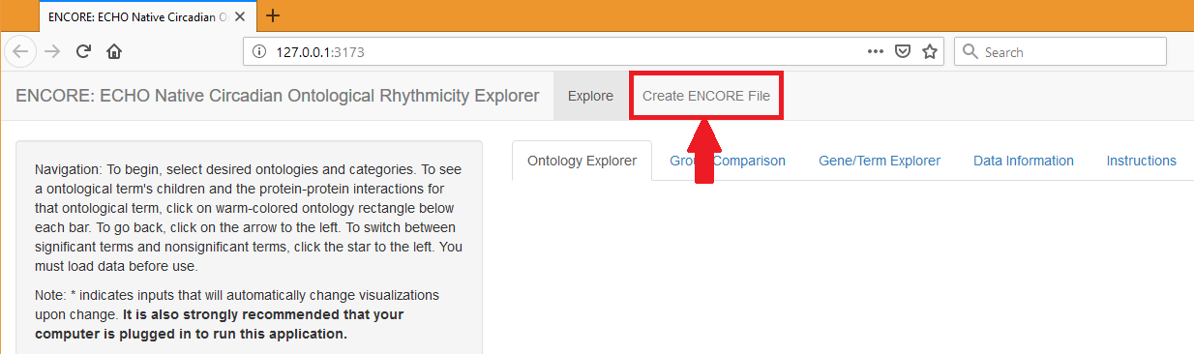

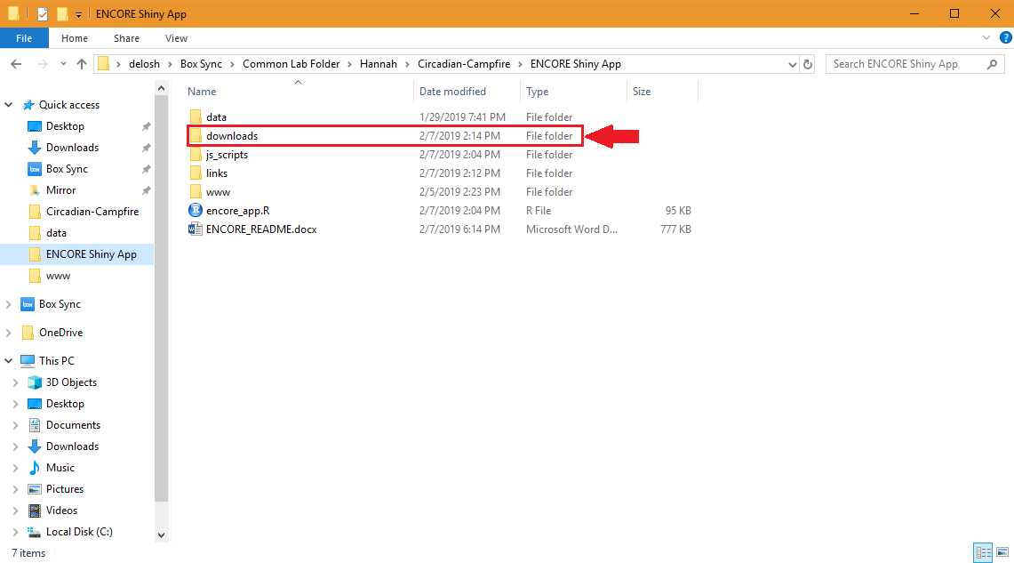

1. Once you’ve downloaded the ENCORE file, upload it to the ‘Explore’ section and proceed, following the navigation instructions.
2. Have fun!

* Why do I have to install either Firefox or Chrome, you ask? Why not Internet Explorer, or some other browser? Well, it is known there are problems downloading files when viewing shiny apps in Internet Explorer, as well as some aspects of d3 not working, so we definitely want to avoid that. However, I have not tested this app in browsers like Microsoft Edge, Safari, etc. If you can verify that these work, please let me know at delosh@rpi.edu.